HCA Disclosure Document Packets Procedure

- Sellers request a HCA Disclosure packet via the HCA email address (or via a link accessible via the HCA website?)

- If request for a Disclosure Packet comes via the HCA email address, the Board directs the seller to homewisedocs.com where they will need to Sign Up in order to request a packet.

The first screen a user will see is this:

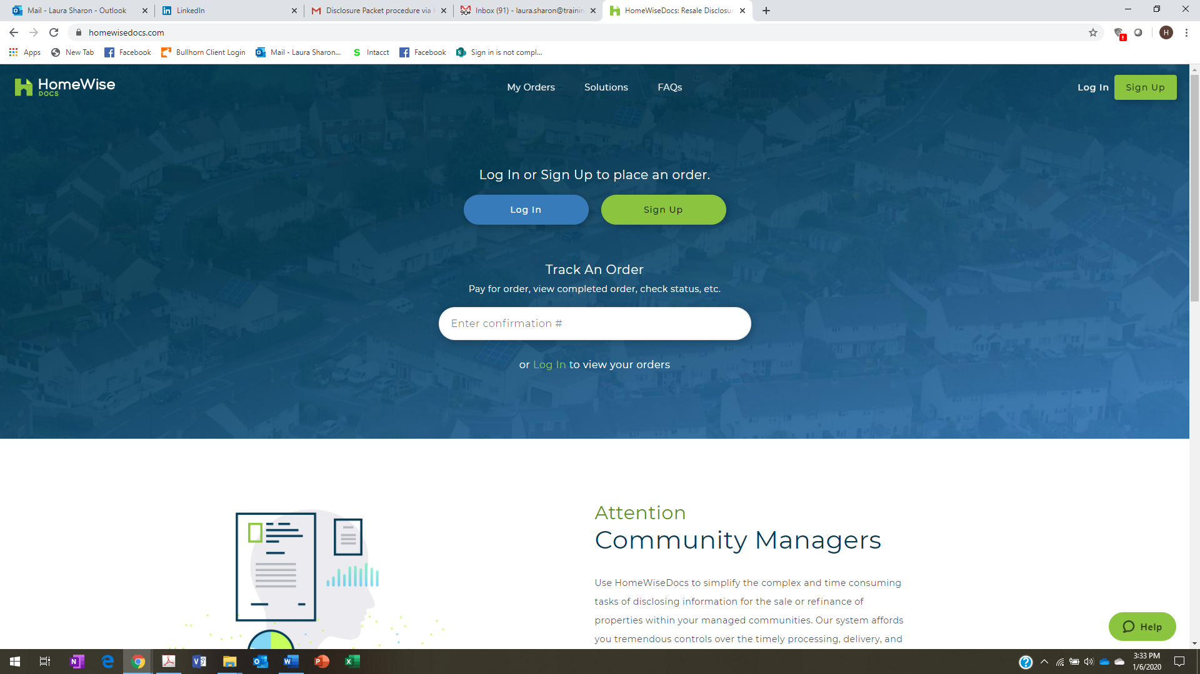

- Once a user creates their account, including creation of a password, the system takes the user to this next screen:

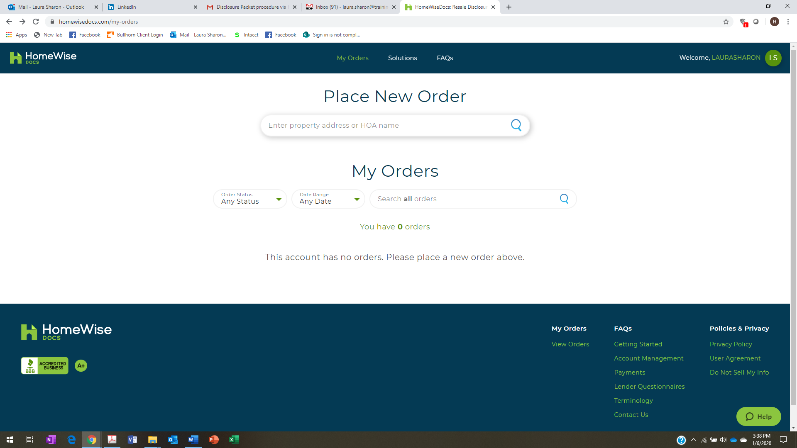

- User then enters ‘Hillcrest Cluster Association in the space under place new order. Doing this will result in the user seeing the following info:

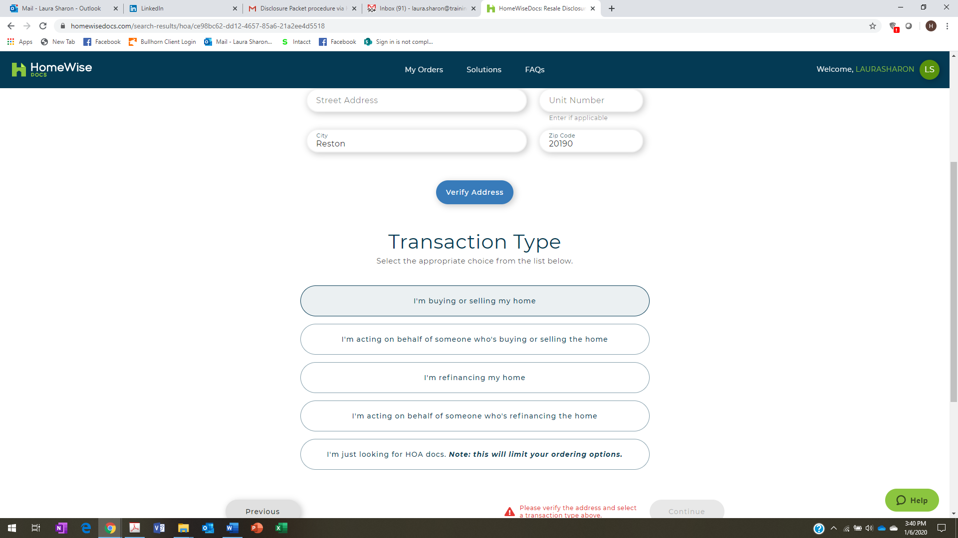

- They then select ‘I’m buying or selling my home’ button.

- Once the user verifies their address, the system will take them to the following screen where the user selects the box in the right-hand column of the navy blue section of the page.

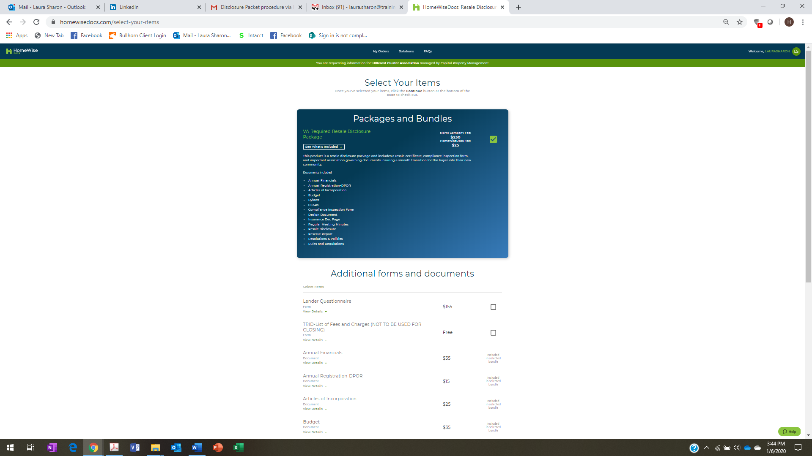

- Sellers have an option to pay the fee upfront, or to pay at closing. Per Capitol, most sellers choose to pay at closing.
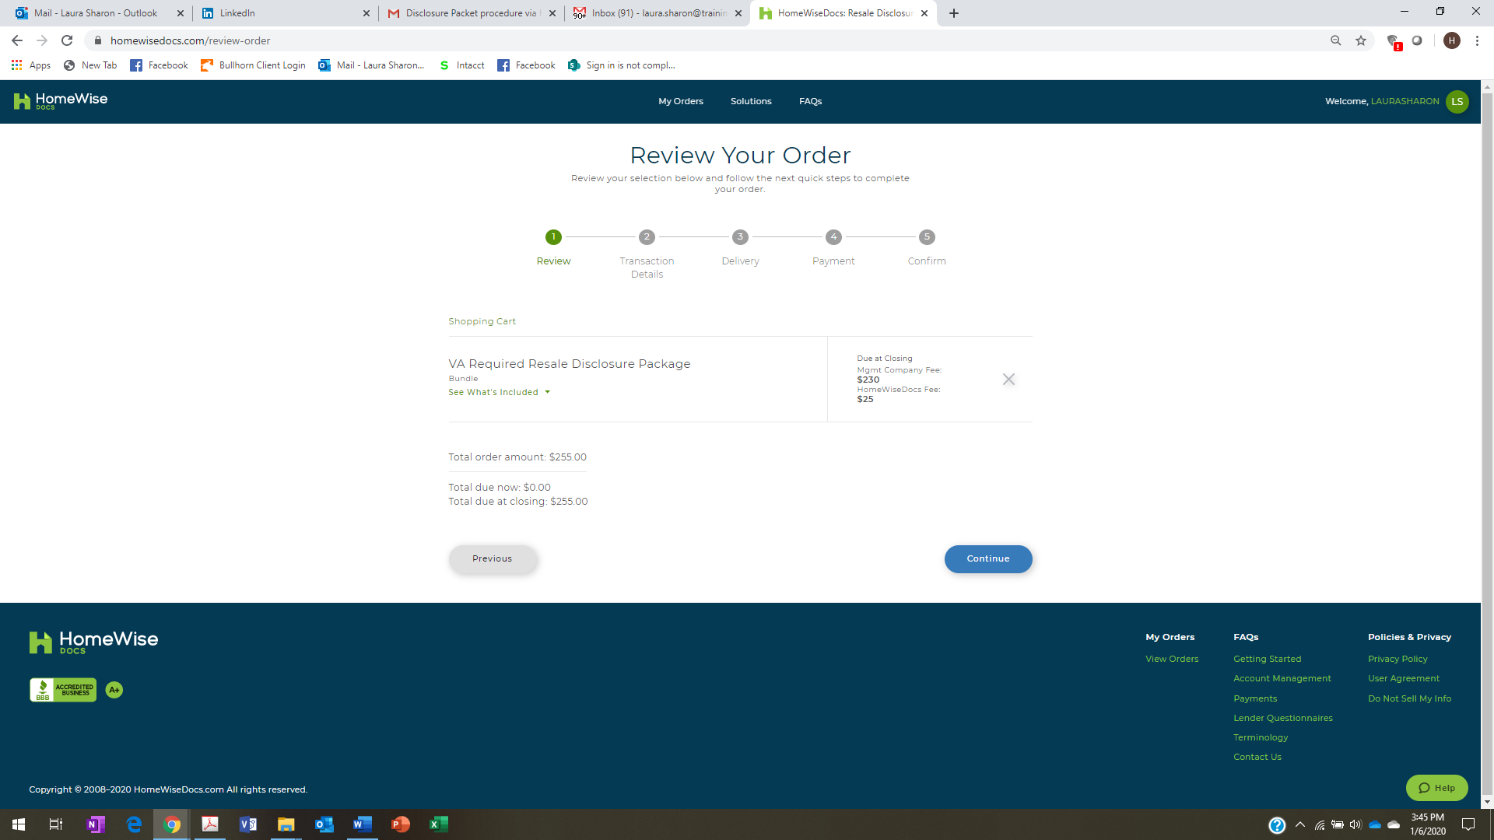

- User then completes the next form:

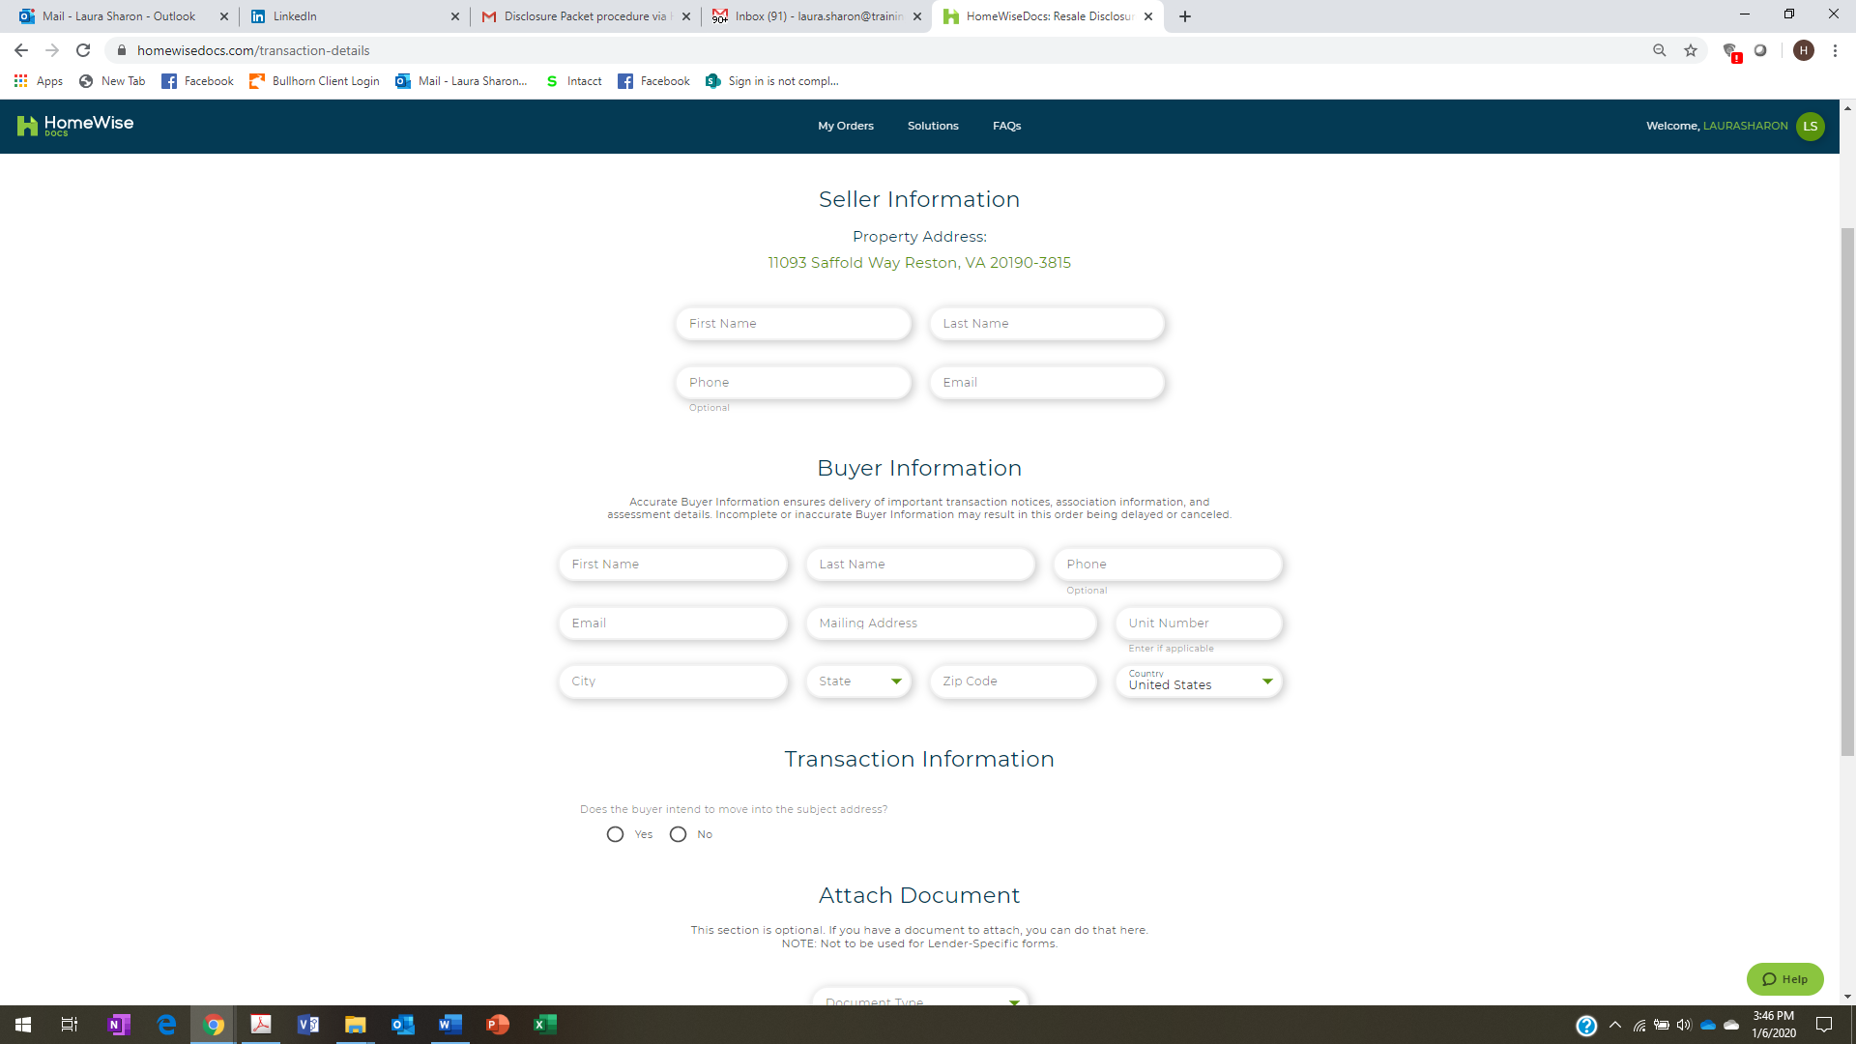

- User completes the rest of the steps, using the navigation bar at the top of the page to guide them in completing all steps.

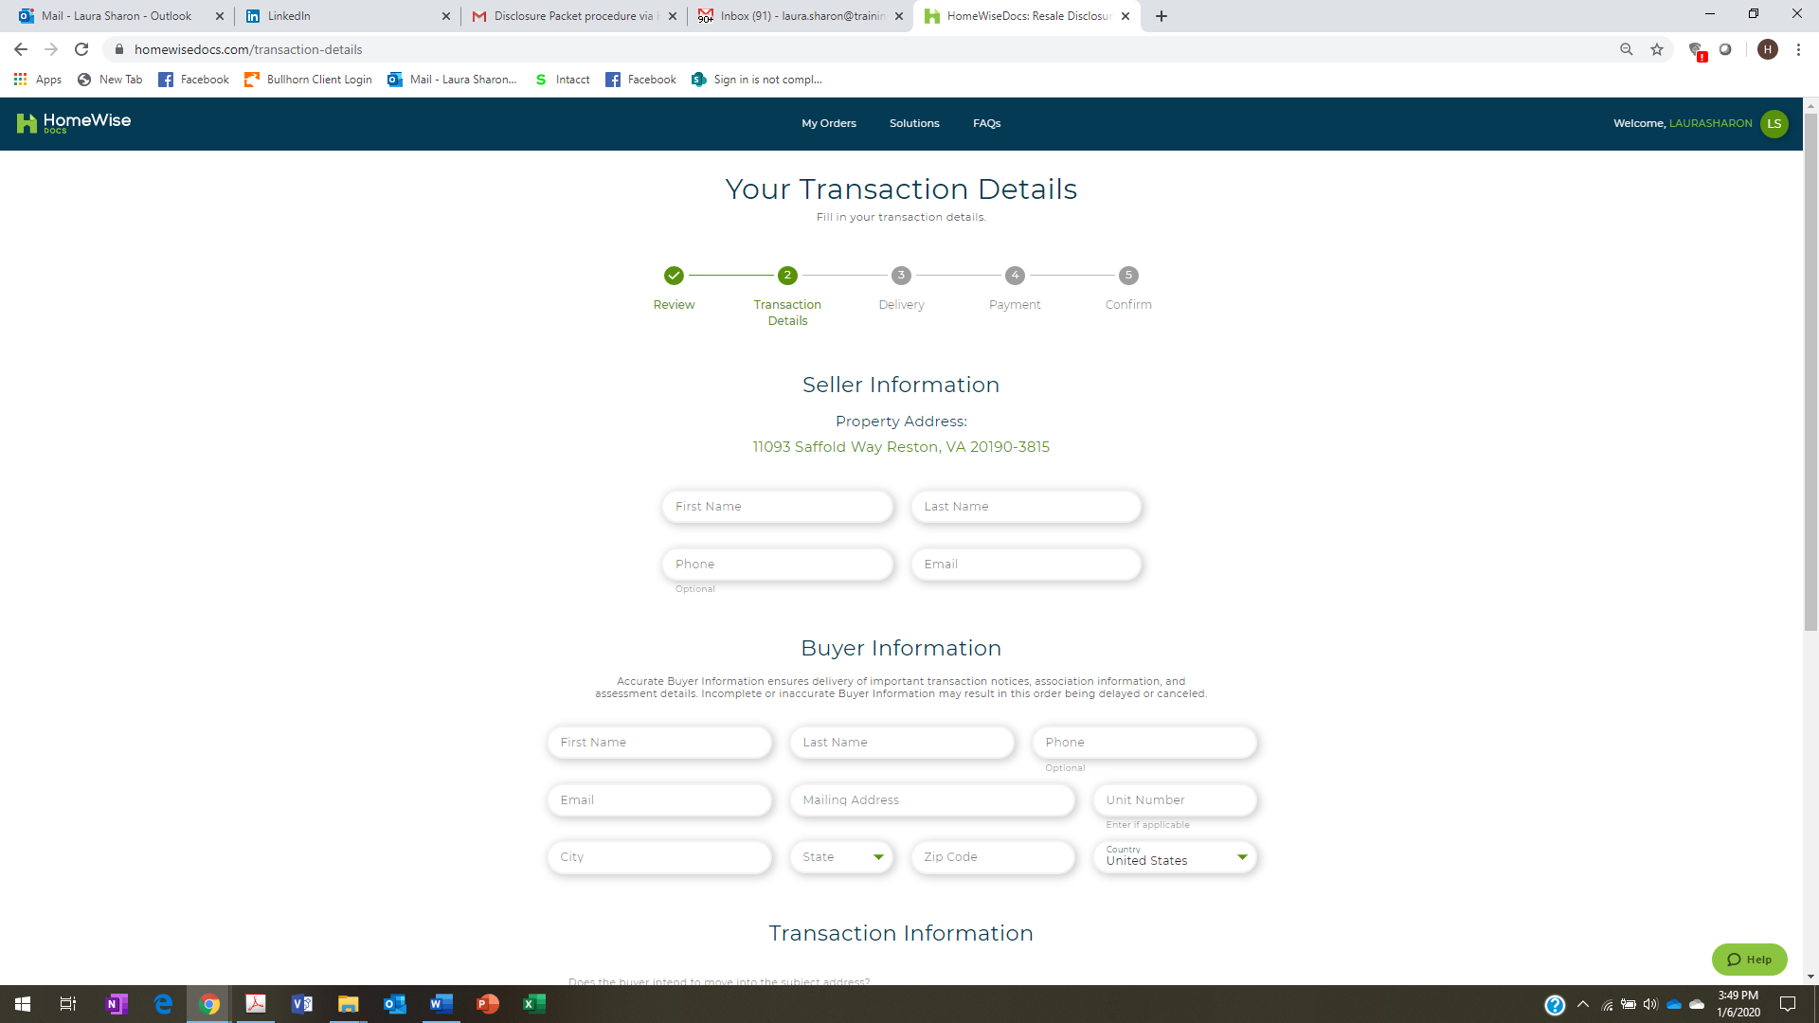

- Once the request is completed through Homewise, both the Cluster board and our Property Management Company which produces the disclosure packets on our behalf will be notified. An inspection of the home will occur, and will be compiled into the disclosure packet and made available to the requesting party.

